

READING AND WRITING XML FILES

Mahnoor Butt



June 13, 2016

DUFFERIN-PEEL CATHOLIC DISTRICT SCHOOL BOARD

ICS4U1 - CPT

Table of Contents

WHAT IS XML? 3

Pros and Cons 3

XML Parsing and Parsers 3

XML PARSERS 3

Document Object Model Parser 4

Codes used 4

References……………………………………………………………………………………………………………………………………………………………5

2

# WHAT IS XML?

XML is an abbreviation for

E**X**tensible **M**arkup **L**anguage

Markup Language is a computer language that uses tags to define parts and components of a document. Tags  
are used to specifies how the document should be formatted.

XML is a markup language for documents that contain structured information. It is designed to store and carry data. XML is different from HTML because XML has tags that are not predefined. Tags are created depending on the application.

XML documents are not only used for traditional documents, but are also used for many other types of files such as:

→ Database Access

→ E-commerce transactions

→ Mathematical equations

→ Application program interface (APIs) and more

# Pros and Cons

PROS:

* Can easily be read and understood by someone who does not have little or no knowledge of code.
* Custom tags can be created and used easily

CONS:

* The code has terms that are repeated many times which causes the file size to increase.

# XML Parsing and Parsers

To be able to read and modify XML documents, it needs to go through a process called parsing. Parsing is needed so the file can read and modify the document.

## XML PARSERS

XML parsers are a way to access and modify the data in an XML file. It is a kind of program that can break up an XML file into more meaningful pieces. Java provides multiple ways to parse XML documents. One of the commonly parsers that are used for XML files are:

* DOM Parser
* SAX Parser
* JDOM Parser
* StAX Parser and more

3

## Document Object Model Parser

Document Object Model (DOM) parser is most used and recommended for reading and handling the document. It can be updated to change the style, structure, and contents of an XML document. When parsing with the DOM parser, you get back a tree structure that contains all the elements (name of the tags) of the XML file

# Codes used

BASE CODE:

<myElement>some content here</myElement>

<elements>

 <myelement>one</myelement>

 <myelement>two</myelement>

</elements>

<?xml version="1.0"?>

<productListing title="ABC Products">

 <product id="1">

   <name>Product One</name>

   <description>Product One is an exciting new widget that will

     simplify your life.</description>

   <cost>$19.95</cost>

   <shipping>$2.95</shipping>

 </product>

 <product>

   <name>Product Two</name>

   <description>This is such a terrific widget that you will

     most certainly want to buy one for your home and another one

     for your office!</p>

   <cost>$24.95</cost>

   <shipping>$0.00</shipping>

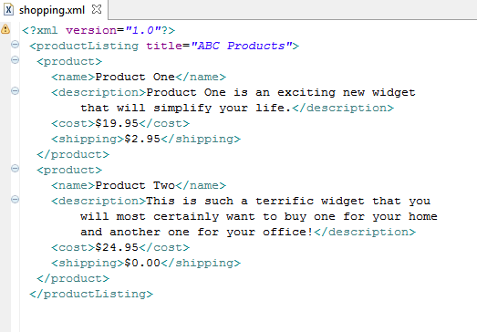  </product>

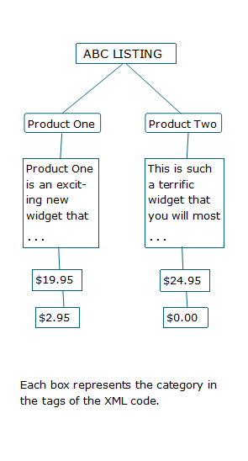 </productListing>

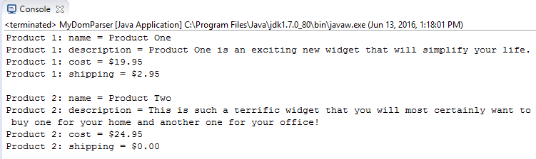

4

# References

*A Really, Really, Really Good Introduction to XML*. (2005). *SitePoint*. Retrieved 10 June 2016, from https://www.sitepoint.com/really-good-introduction-xml/

*Diagram of DOM parser*. (2016). Retrieved from https://wiki.scn.sap.com/wiki/download/attachments/78053807/dom.JPG?version=2&modificationDate=1234266903000&api=v2

*Introduction to XML - Aspose.Pdf for Java - Documentation and Developer Guide for Aspose APIs*. (2016). *Aspose.com*. Retrieved 10 June 2016, from http://www.aspose.com/docs/display/pdfjava/Introduction+to+XML

*Java Online Training | Parsing XML using Java DOM Parser*. (2016). Retrieved from https://www.youtube.com/watch?v=HfGWVy-eMRc&ab_channel=FireboxTraining

*Java XML Quick Guide*. (2016). *www.tutorialspoint.com*. Retrieved 12 June 2016, from http://www.tutorialspoint.com/java_xml/java_xml_quick_guide.htm

Lynda.com,. (2016). *Parsing an XML file with DOM*. Retrieved from https://www.youtube.com/watch?v=GpNuGNM6HZ4&ab_channel=VideoDustBin

*Picture of a tag*. (2016). Retrieved from http://www.ironpaper.com/webintel/wp-content/uploads/2013/11/code2-400x400.png

*Trail: Java API for XML Processing (JAXP) (The Java™ Tutorials)*. (2016). *Docs.oracle.com*. Retrieved 12 June 2016, from https://docs.oracle.com/javase/tutorial/jaxp/

Walsh, N. (2016). *XML.com*. *Xml.com*. Retrieved 12 June 2016, from http://www.xml.com/pub/a/98/10/guide0.html?page=2

5